Key Dates
Please note that the following dates relate to actions to be taken during the 2016/17 tax year:

6th April 2016
Tax Return for 2015/16 or a notice to complete a Return will be issued.

31st July 2016
Second payment on account of 2015/16 income tax and Class 4 NIC liability

31st October 2016
Paper Tax Return for 2015/16 to be submitted

30th December 2016
Tax Return to be filed online if you want a tax underpayment of less than £3,000 collected via your 2017/18 PAYE code

31st January 2017
Online Tax Return for 2015/16 to be submitted with self-assessment payment of balance of income tax and Class 4 NICs for 2015/16 and payment of capital gains tax for 2015/16

First payment on account of 2016/17 income tax and Class 4 NICs (normally half the total 2015/16 income tax and Class 4 NIC liability, adjusted for tax deducted at source)

Information deadlines
So that employees can complete their Tax Returns, information deadlines are imposed on employers:

- Form P60 must be provided to employees by 31 May following the end of the tax year
- Copies of forms P11D and P9D must be provided to relevant employees by 6 July following the end of the tax year
- Form P45 has a part for the employee to retain

For more information on how we can assist you, please contact us.

Our Services
Business Planning | - Business start-up planning and advice  - Strategic and business planning  - Financial management  - Financial information systems  - Computer systems advice
Taxation Advice | - Self Assessment  - Personal tax  - Business tax  - Company tax  - Capital gains tax  - Inheritance tax  - HM Revenue & Customs investigations  - Value Added Tax  - PAYE and national insurance compliance
Accounting | - Preparation of annual accounts  - Preparation of periodic management accounts  - Bookkeeping services  - Maintaining PAYE and VAT records and associated returns
Company Secretarial | - Preparation and filing of statutory returns  - Preparation of minutes and resolutions  - Company formation  - Company searches

This guide is for general information only. No responsibility is taken for any action taken or refrained from in consequence of its contents. Always seek professional advice before acting.

Please contact us for further information.

V J Hancock & Co Ltd
The Long Barn, The Old Brewery, Priory Lane, Burford, Oxfordshire, OX18 4SG
Tel: 01993 822817
Email: info@vjhancockandco.ltd.uk
Website: www.vjhaccountancy.co.uk



2016/17 Guide to Self-Assessment

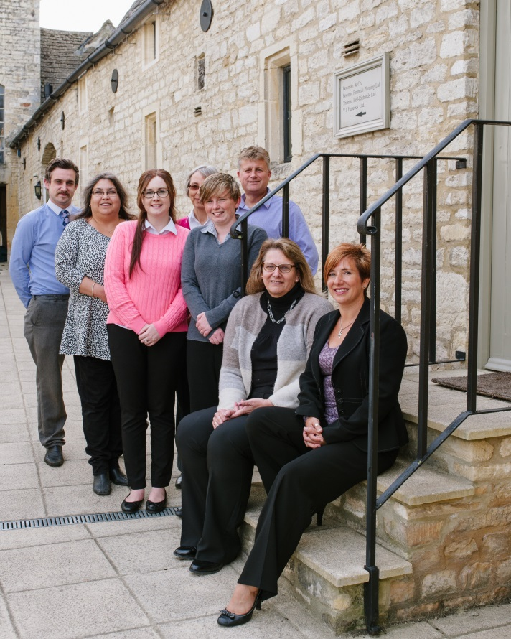

V J Hancock & Co Ltd
The Long Barn, The Old Brewery, Priory Lane, Burford, Oxfordshire, OX18 4SG
Tel: 01993 822817
Email: info@vjhancockandco.ltd.uk
Website: www.vjhaccountancy.co.uk

Your Guide to Self-Assessment
It is a fundamental part of the self-assessment system that responsibility lies with you, the taxpayer, to file Returns and pay the right amount of tax, at the right time – you must not wait for HM Revenue & Customs (HMRC) to ask.

Tax Returns
Tax Returns covering income for the year ending 5th April 2016 will be issued on or after 6th April 2016, and will consist of a main Return and supplementary pages. Your tax office will sent out those pages they think you will need. If you need other pages, these will have to be requested or downloaded.

The completed Return has to be submitted to HMRC by the ‘filing date’ (31st October 2016 for paper Returns, 31st January 2017 for Returns filed online).

You should note that figures must be given for every item, even if these are only estimates. It is not possible to enter question marks or leave the tax inspector to decide whether an item is taxable or not. The only section that can be left for the tax office to complete is the actual calculation of the tax due on your total income.

If you have taxable income or capital gains for 2015/16 and have not received a Tax Return, you must advise your tax office by 5th October 2016 at the latest.

There are automatic penalties for late filing of Tax Returns. Failure to file the Tax Return by the filing date incurs a £100 penalty. If it has still not been returned 3 months later, daily penalties of £10 per day will accrue, running for a maximum of 90 days. There will be further penalties of 5% of tax due for the return period (or £300 if greater) for prolonged failures, which arise after 6 months and again after 12 months.

We can prepare your Tax Return for you, file it with HMRC and advise on the appropriate payments to make. If there is an enquiry in to your Tax Return by HMRC, we can provide assistance. Additional costs may apply.

Returns and Payment
Amendments, enquiries, and record keeping.
You have one year from the filing date to make any amendments to your Tax Return. HMRC may correct obvious errors or mistakes within nine months of receipt of the Return.

Within a period of one year from the date the Tax Return is submitted, HMRC will have a right to make enquiries to check that the Tax Return has been completed correctly. No reason for the enquiry need be given.

All records relating to the Return should be kept for a period of one year from the filing deadline. If trading or rental income is involved, all records should be kept for a further four years.

Determinations
If a Return is not submitted by the due date, HMRC can, within five years of the filing date, make a determination of the best of its information and belief of the amount of tax due.

This amount of tax will be payable without appeal, but will automatically be superseded when the Return and self-assessment are sent in.

Payment of Tax
Payments on account of income tax for a particular tax year are due on 31st January in the tax year and 31st July following the end of the tax year. For these purposes income tax includes Class 4 National Insurance Contributions (NICs).

These payments are set by reference to the relevant amount – the amount by which the total income tax exceeds the amount of any income tax deducted at source. In these cases, the balance of tax due for the year, including capital gains tax, is payable on 31st January following the end of the tax year.

Payments on account are not due where the relevant amount is less than £1,000 or if more than 80% of the total tax liability is met by income tax deducted at source. In these cases, the balance of tax due for the year, including capital gains tax, is payable on 31st January following the end of the year.

You have the right to reduce payments on account if you believe the income tax for the current year will be lower than that for the previous year. However you may be charged interest if the reduction is more than it should be.

Late payment penalties and interest
An automatic late payment penalty of 5% will be levied on any 2015/16 tax outstanding at 2nd March 2017, and further penalties of 5% will apply to any 2015/16 tax still outstanding at 31st July 2017 and 31st January 2018. There is a right of appeal against the penalties on the grounds of reasonable excuse.

In addition, interest will arise on tax (and penalties) paid late, from the due date of payment to the actual date of payment. HMRC will pay interest on amounts overpaid, from the date of payment (or the due date if later) to the date of repayment.

Self-Assessment for employees
For employees, self-assessment is comparatively straightforward. The PAYE system means most employees should pay the correct amount of tax at source. An employee with a relatively straightforward tax situation is unlikely to be asked to complete a Tax Return.

Tax Codes
The main cause of under- or overpayments of PAYE is actual benefits-in-kind being different from the estimates included in the tax code. If there is an underpayment of less than £3,000 for 2015/16, HMRC will try to adjust the 2017/18 PAYE code to collect the underpayment. Self-assessment allows taxpayers who have a PAYE code to carry forward underpayments in the same way provided the return is filed by 30th December 2016. The taxpayer has the option of paying the outstanding tax by the normal payment date of 31st January 2017.

Simpler tax for small businesses
From April 2013 a new optional cash basis is available for the purposes of calculating taxable income for small unincorporated businesses. The system works on a cash flow basis. For income, it is what the business receives, when it is received; for outgoings, it is what the business pays, when it pays it. Receipts include all amounts received in connection with the business. Allowable payments are expenses paid wholly and exclusively for the purposes of the trade. All unincorporated businesses may choose to use flat rate expenses for particular items of business expenditure – the use of vehicles, the use of home and an adjustment for private use of business premises.

